GT-2000 SERIES MULTIFUNCTIONAL GAS ANALYZER  USER MANUAL  _{深圳市科尔诺电子科技有限公司}  ShenZhen Keernuo Electronics Technology Co.,Ltd | 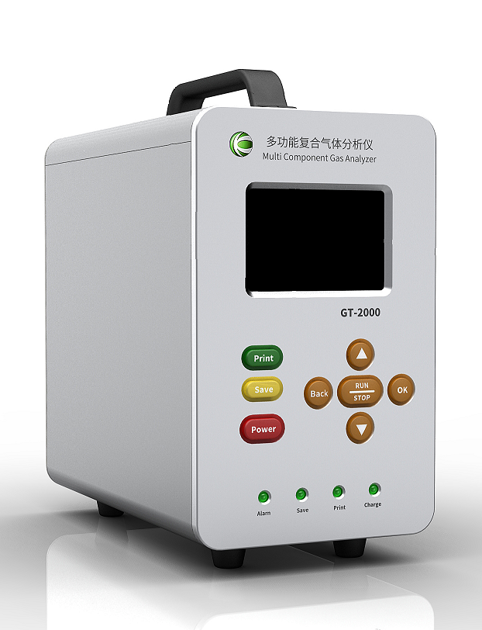

Catalog
Notice - 4 -
1.Product Brief Introduction - 7 -
2.Key Feature - 7 -
3. Technical Parameters - 8 -
4.Product Structure - 10 -
5.Operation Instruction - 11 -
5.1Button Description - 11 -
5.2Power On - 12 -
5.3Power Off - 13 -
6.Operation Interface - 13 -
6.1 Gas Detection Interface - 13 -
6.2 Function Menu Instruction - 15 -
6.2.1 Basic Setting - 15 -
6.2.2 History Data - 16 -
6.2.3 Data Analysis - 17 -
6.2.4 Zero Calibration - 17 -
6.2.5 Target Calibration(Do Not Calibrate Unless You Are Professional) - 18 -
6.2.6 Alarm Settings - 18 -
6.2.7 Data Storage - 19 -
6.2.8 Time Setting - 20 -
6.2.9 Factory Reset - 20 -
7.Other Notice - 20 -
8. Common Faults and Exclusions - 21 -
9.Concentration Datalog Output Instruction - 24 -

Notice
①Button description
There are 8 buttons beneath the display screen: Up,Down,Back,Ok,run/stop,Print,Save,Power,
Three operation interfaces：Detecting interface,Menu,Parameter setting.
The following form is description for the 8 buttons.
 | Detector interface | Menu | parameter setting
Up | Invalid | Up | Move up/ Value+
Down | Invalid | Down | Move down/ Value-
Back | Invalid | Return to previous menu | Return to previous menu
Ok | Enter menu(press and hold for 5 seconds) | Confirm to enter menu | Enter/Select/Save
Run/stop | Pump switch/  Timing detection switch | n/a | n/a
Print | Print instant gas concentration data | n/a | n/a
Save | Save instant gas concentration data | n/a | n/a
Power | On/Off(press and hold for 5 seconds) | On/Off(press and hold for 5 secondseconds) | On/Off(press and hold for 5 seconds)
CAUTION:
GT-2000 series multifunctional gas and dust detector could be work normally only in condition of the pump was switched on
②gas analyzer Processing Operation under Out-range Status
Users should avoid to have sensor impacted by the gas with a pressure value greater than the maximum of the analyzer, which might affect the service life and precision of the analyzer, or even directly damage the analyzer.
When a user accidentally makes out-range operation, he should evacuate the instrument out of the detecting site and place it in the clean air for more than half of an hour. During the time, user should observe whether the density value of the instrument is keeping decreasing or not. If it can straightly go down to normal value, then he can continue to use it after the zero calibration of instrument. While the instrument after the out-range operation and user has placed it in clean air for hours, the density value remains high, then it should be sent back to the manufacturer or agent for maintenance, be ready to replace the sensor.
Special Note: Detector damage resulted from out-range operation is not within the warranty.
③Detector Calibration and Warranty
We guarantee all analyzer were precise calibrated with certain density standard gas. It’s not necessary for customer to re-calibrate the analyzer after purchase unless encounter special situation. Also the calibration need to be operate under the guidance of the professional.
We provide 12-Mounths warranty for the analyzer and 3-Mounth warranty for the accessories. Beside,we have free calibration once a year during the entire product’s service life.
④Instruction of analyzer display dimmed
Power capacity protection program had been preset for GT-2000 multifunctional gas analyzer, when no operation were made within 30 seconds the protection program will activate and the display of the analyzer will dim out,user can light up the display by press any button.
⑤GT-2000 Hot Key Instruction
Mute: When analyzer is in the state of alarming user can mute the analyzer by pressing the “Up”or “Down”button.
Save and print manually:When storage mode was preset as manually,User can save concentration data of each channel by pressing “Save” and hearing a “DI” sound,history data can be view in the “History data” menu.press print to print instant gas concentration of each channel(Printer connected is required)
Enter function menu: When analyzer is in the detection menu user can enter system menu by pressing “Ok” button for 5 seconds
⑥Parameter modification instruction
User can modify all parameters by “Back”,“Up”,“Down”,“Ok”buttons.

1.Product Brief Introduction
GT-2000 multifunctional gas analyzer is portable gas analyzer/alarm which can be configure flexibly up to 6 gas sensors.With import gas sensor and most advance nanometer semiconductor technology GT-2000 multifunctional gas analyzer can detect
corresponding gas concentration at the same time rapidly and precisely,we maintain a leading position in domestic level and our products are famous of high stability and repeatability .User can custom setting all parameters to ensure the operations are user-friendly.6000mA built-in high capacity polymer rechargeable battery,technical indicators,gas concentrations and history data can be display in the 3.5 inches IPS technical grade screen,User can save concentration data,print and output data,detect temperature and humidity level.

2.Key Feature
- With the most advance nanometer semiconductor technology ,ultra low power 32bit microprocessor,24bit ADC data acquisition chip,outstanding accuracy.
- 3.5 inches IPS technical grade display with a pixel up to 320*480,display technical indicators and gas concentration value perfectly.
- Three concentration units are available PPM,%VOL,mg/m3.
- User can combine different sensor,1-6 kinds of gas can be detect at the same time,temperature and humidity sensor and other kind of sensors are available.
- Up to 100,000 group data can be storage,user can view history data on the display and data output is available.
- With temperature and humidity detection,user can detect temperature and humidity value
- Four operation modes are optional:Detection mode,Storage mode,Display mode,Pumping mode.
- With high-power pump allow device working under tiny negative pressure condition,the reasonable gas chamber design ensures that the sensor is not affected by the pressure.
- With over-voltage protection,overcharge protection,electrostatic prevention,magnetic-field interference prevention
- All software automatic calibration, sensor up to 6 levels target calibration,ensure the accuracy and linearity of the entire measurement,also with data recovery function.
- Chinese and English operation model are available,user-friendly.
- With temperature and humidity compensating function.With dust filter and dust-proof design allow device applies in all sorts of harsh conditions.

Technical Parameters
Product type： | Multifunctional gas analyzer(Customize according to user’s need)
Scalable gas sensor: | User can customize 1-6 gas sensors in any combination,please refer to the sensor parameters
Temperature and humidity: | Temperature detection range:-40 ～ 120℃  Humidity detection range:0-100%RH
Detection pattern: | Pumping,with built-in high-power pump allow device working under tiny negative pressure condition
Indication accuracy: | ≤±3%F.S |  | Linearity error: | ≤±1%F.S
Response Time: | ≤20 S（T90） |  | Zero drift: | ≤±1%（F.S/Year）
Recovery Time: | ≤20 S |  | Repeatability: | ≤±1%F.S
Detection Mode: | Real-time detection mode and timing detection mode can be switch freely
Storage pattern: | Automatically saving and manually saving is available,Up to 100,000 group data ,user can view history data on the display.
Explosion proof sign： | Exdll CT4 (IA) | Shell material: |  | Aluminium
IP rating: | IP6 | Operating temperature: |  | -30 ～ 60℃
Power Supply: | 6000mA high capacity polymer rechargeable battery | Operating humidity: |  | ≤95%RH，Without Condensation Non-condensing
Dimensions and Weight: | Approx. 230*120*220 mm（L×W×H）  Approx. 3.0 Kg（net weight） | Working pressure: |  | -30Kpa ～ 100Kpa
Accessories: | Case,User manual,Certification,12V DC Charger,USB cable,Sampling handle,0.8M tube

4.Product Structure
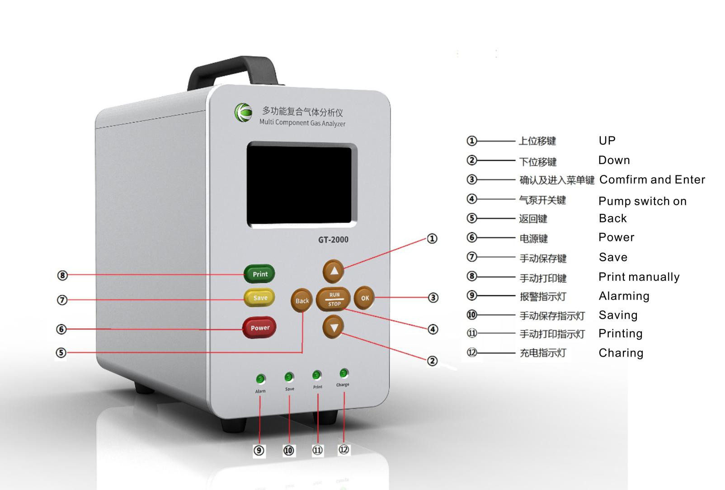

5.Operation Instruction

5.1Button Description
There are 8 buttons beneath the display screen: Up,Down,Back,Ok,Run/stop,Print,Save,Power
Three operation interface：Detector interface、Menu、Parameter setting.
The following form is description of the 8 buttons.
 | Detector interface | Menu | parameter setting
Up | Invalid | Up | Move up/ Value+
Down | Invalid | Down | Move down/ Value-
Back | Invalid | Return to previous menu | Return to previous menu
Ok | Enter menu(press and hold for 5 seconds) | Confirm to enter menu | Enter/Select/Save
Run/stop | Pump switch/  Timing detection switch | Invalid | Invalid
Print | Print instant gas concentration data | Invalid | Invalid
Save | Save instant gas concentration data | Invalid | Invalid
Power | On/Off(press and hold for 5 seconds) | On/Off(press and hold for 5 secondseconds) | On/Off(press and hold for 5 seconds)

CAUTION: GT-2000 multifunctional gas analyzer will perform normally Only in condition of the pump was switched on

5.2Power On
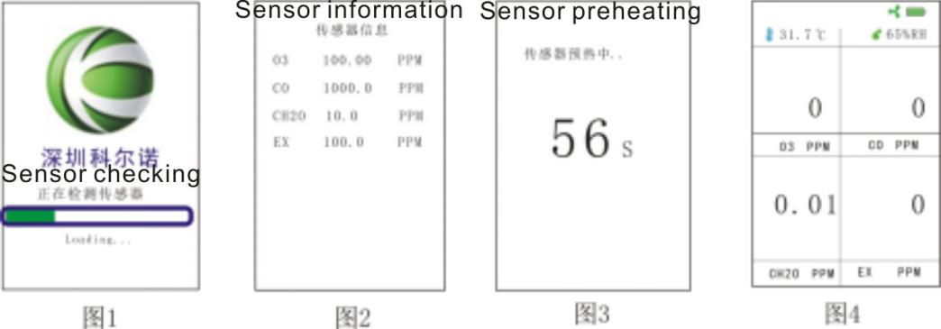
Long press power button for five seconds until the “DI” sound then the display and red signal light turn on,The screen appears:Sensor checking (3 seconds),Sensor information(1 second) ,Sensor preheating and automatically start the pump(60 seconds count down)in sequence as it show in figure 1-3,analyzer will start after the count down and enter detection interface as it show in figure 4

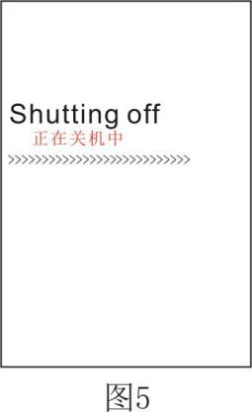
5.3Power Off
In normal detection mode long press power button for five seconds until the “DI” sound ,display shows shutting down as it show in figure 5,device will be shutoff within 1 minute .

6.Operation Interface

6.1 Gas Detection Interface
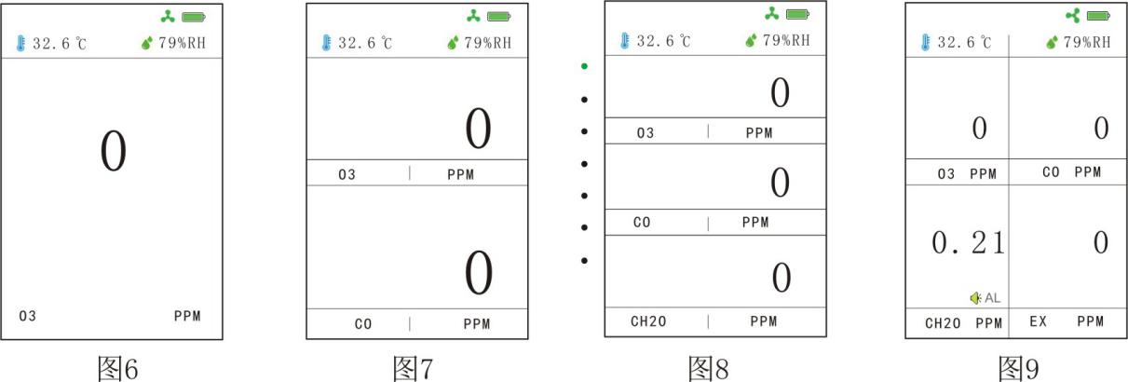
Under normal-detection mode,according to the number and types of sensors in the device,there are different interfaces: single gas detection mode as shown in figure6(O3 for example),two kinds of gas detection mode as shown in figure 7 (O3、CO for example) ,three kinds of gas detection mode as shown in figure 8(O3、CO、CH2O for example),four kinds of gas detection mode as shown in figure 9(O3、CO、CH2O,Combustible gas for example).
Icons at the left top of the the display (refer to figures above) are time and temperature, at the right top of the display shows the “pump status”,”battery capacity”,”humidity”,take figure 9 for example,there are four channels ,channel 1 at the left top(O3),channel 2 at the right top(CO),channel 3 at the lower left(CH2O2),channel 4 at the lower right(EX);figure indicate corresponding gas concentration in each channel,lower left”o3” is the gas’s molecular formula,lower right”PPM” is the concentration unit;when one or several gas channel reach the alarm value,there will be a alarm sign under corresponding concentration figure,as shown in figure 9 the CH2O channel is alarming.

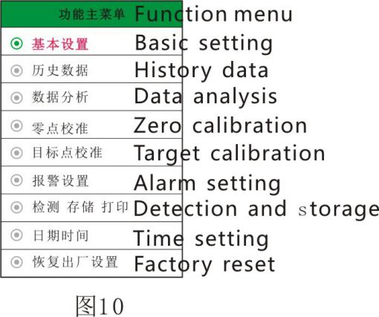
6.2 Function Menu Instruction
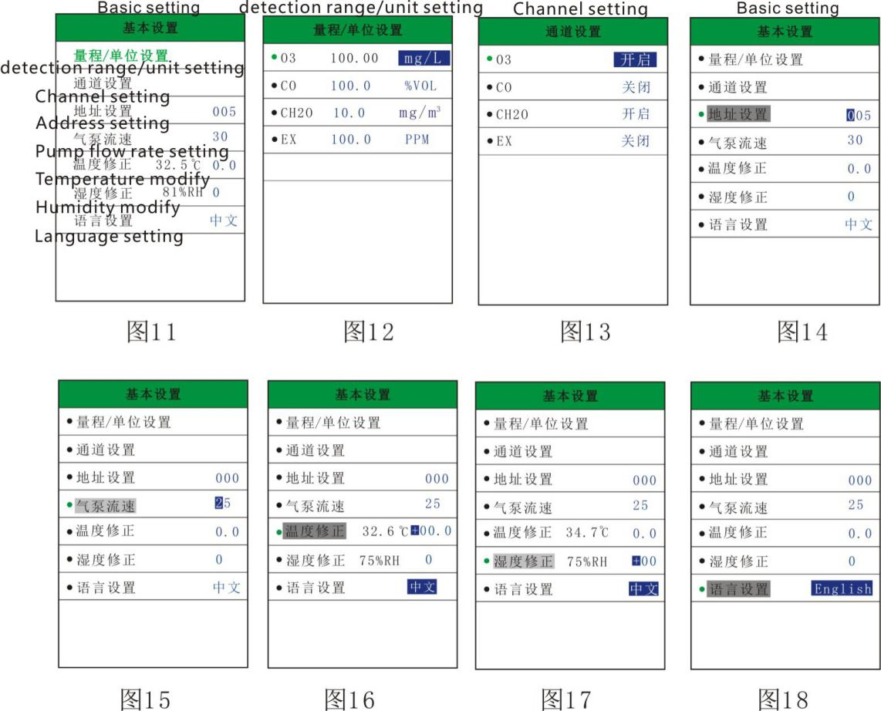
Long press”OK” button for 5 seconds to enter function menu as shown in figure 10. Nine sub-menus are including in function menu:Basic setting、History data、Data analysis、Zero calibration、Target calibration、Alarm setting、Detection and storage、Time setting、Factory reset.In main menu move the cursor to different sub-menu by press “Up” and “Down”button,press “Ok” to enter corresponding sub-menu,press “Back” to return to normal detection interface.

6.2.1 Basic Setting
In Basic setting menu user can see various setting as shown in figure 11,press “Up” and “Down” button to move the cursor , press “Ok”to enter sub-menu and modify parameters.
- Range/Unit setting:(as shown in figure 12)User set detection range and units( ppm,mg/m³,%VOL)of different gas
- Channel setting:In this menu user can set to activate/shield one or various gas channels as shown in figure 13,and also allow user to check channel address.
- Address setting:(as shown in figure 14)User can set analyzer address in this menu,the defaulted address is 255, this address is for connect to host computer.
- Pump flow rates:In this menu user can adjust the intake air flow rate of the pump as show in figure 15(Normally require preset under condition of negative pressure,defaulted value is 25).
- Temperature modify:In this menu user were allow to modify the temperatur parameter manually as shown in figure 16.
- Humidity modify:In this menu user were allow to modify the humidity parameter manually as shown in figure 17.
- Language setting:User can change system language to Chinese or English in this menu.

6.2.2 History Data
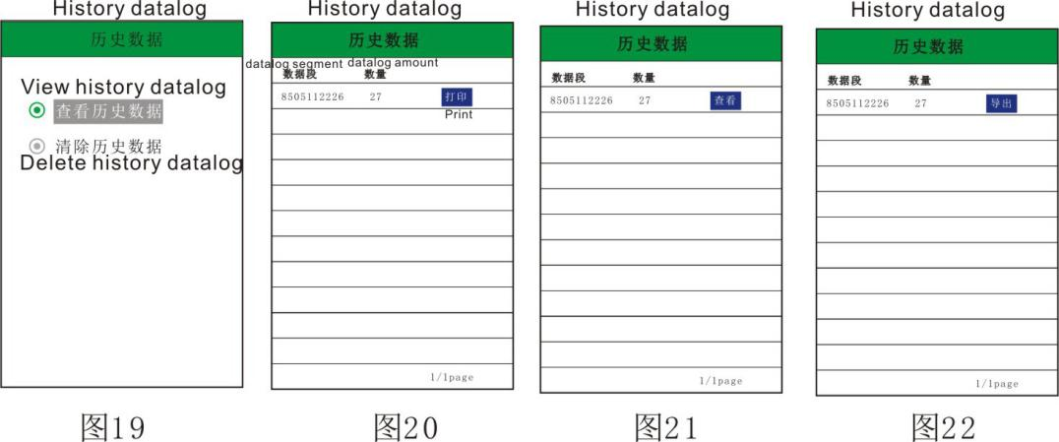
User can view previous gas concentration data or delete history data in “history data” menu as shown in figure 19.
Enter “View history data” interface remain the cursor at “View” and press “Ok” then press “Up” or “Down” to switch between View,Print,Output as shown in figure 20-22.For example in View menu press “Ok” user can view all previous concentration datalogs as it shown in figures 23-24.

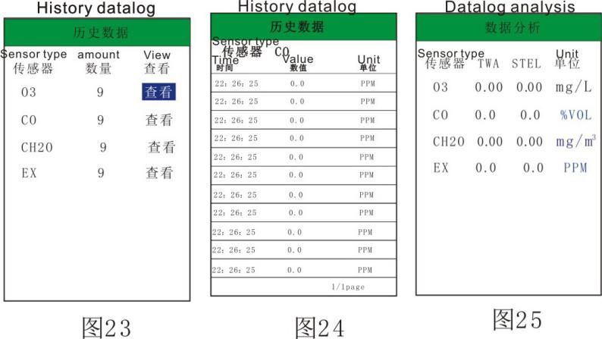
6.2.3 Data Analysis
analyzer can automatically storage and analyze average concentration and highest concentration of various gases being detected during whole working period and shown in “data analysis” menu.TWA stand for average concentration,STEL stand for highest concentration as it shown in figure 25.

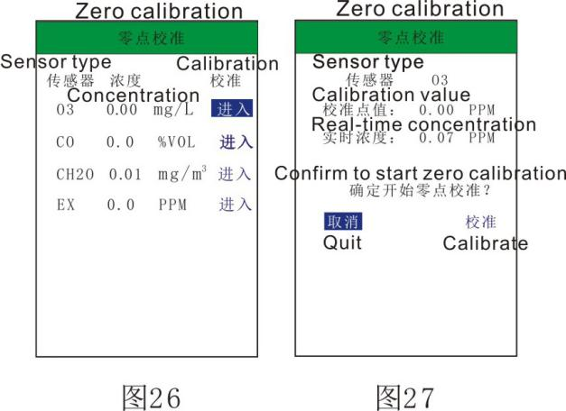
6.2.4 Zero Calibration
If zero drift of the sensor is over range, user can proceed zero calibration ,the gas concentration are defaulted set to zero after zero calibration as shown in figures 26-27.
Special Note: Zero calibration must be proceed in fresh air or high-purity inert gas(for example 99.999%VOL N2 etc)

6.2.5 Target Calibration(Do Not Calibrate Unless You Are Professional)
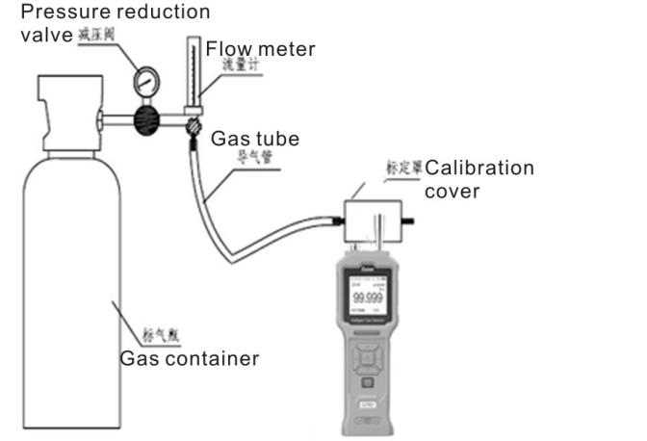
GT--2000 gas analyzer provide 6 levels target gas concentration calibration,as shown in figure 28,this calibration should be operate under conditions of certain standard concentration gas, Pressure reduction valve ,Flow meter, Calibration cover and make sure all instruments are well connected, otherwise this function is forbidden.
Procedures: Connect all instruments as shown in figure 11,enter target gas calibration interface,release standard gas slowly and control gas flow within 500ml/min,observe the real-time concentration value(concentration value should be increasing),wait until real-time concentration value rise to the peak reading and stay still, user can chose a un-calibrate option to operate(√ stand for this level has been calibrated and × stand for this level still need to be calibrate);first of all input a concentration value of standard gas then calibrate. Target gas concentration value will set up to be the standard gas concentration value after calibration.

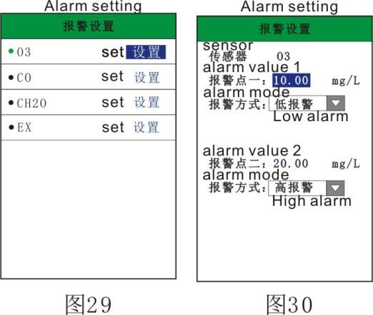
6.2.6 Alarm Settings
User can set the alarm limit and alarm mode in this menu, as shown in figures 29-30,there are two alarm value setting, which are high alarm and low alarm. When user set as the low alarm mode, it will trigger alarm when real-time concentration is lower than preset value , when user switch to high alarm mode, it will trigger alarm when real-time concentration is higher than preset value.
Procedures: Enter alarm settings sub-menu, Move the cursor to “alarm mode”,press “Ok” to select and press “Up” and “Down” to switch alarm mode, then press “Ok” to save your modification.

6.2.7 Data Storage
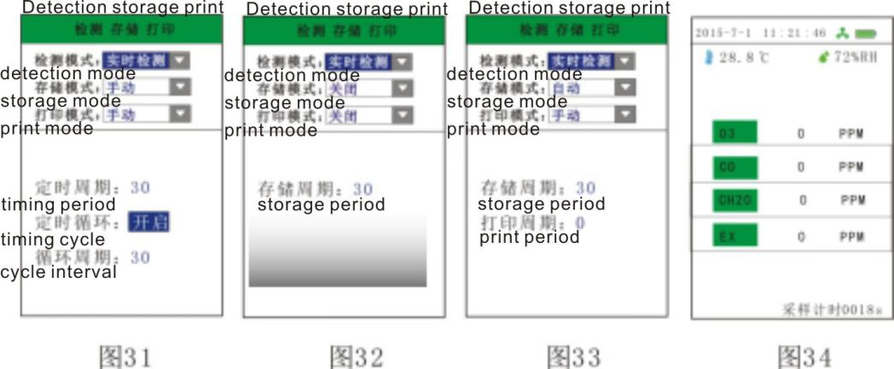
User can set detection mode and storage mode in this menu.real-time detection and timing detection are optional in detection mode .manually save 、automatically save and close(not save) are optional in storage mode.
When analyzer is preset as “real-time detection mode”,it provides continuous monitoring and will shows real-time concentration of each channel in the display,the instrument offer three options for data storage(Manually,Automatically,Not save),it also allows user to set storage cycle under automatically storage mode.
As it shown in figures 31-32,the device will detect the average concentration value of a certain time period when preset as “timing detection mode”,it allows user to set timing cycle and cycle interval(interval of two timing detection),as shown in figure 33,instrument will store the average concentration value of each periodic detection.
User need to return to detection interface and press “Run/Stop”button to activate the countdown after finish the setting of timing detection,as shown in figure 34,if the periodic detection mode is not activated,gas pump and detection process will automatically stops.

6.2.8 Time Setting
Time setting menu allow user to set date and time,this time is related to the time of the concentration values are being recorded.

6.2.9 Factory Reset
If user proceeded an wrong operation by accidentally or need to reset all parameters to factory setting,you can reset all parameter to factory setting.

7.Other Notice
- Please read User Manuel carefully before use the analyzer.
- It is strictly forbidden user to disassemble the analyzer or replacement parts.
- Installation, adjustment, calibration and parameters setting must be progress by professionals.
- Regular inspection of calibration is necessary, expired or broken sensor should be replace immediately.
- It is strictly forbidden to impact sensor with gas which is over detection value.
- User should prevent drop or impact the analyzer.
- It is strictly forbidden to use analyzer in high temperature, high humidity or high pressure environment ,if workingenvironment is high humidity, analyzer need to equip with vapor filter.
- Man-made damage is not within warranty.
- To reduce the risk of ignition of hazardous atmospheres, recharge, remove or replace the batteryonly in an area known to be non-hazardous.Do not mix old and new batteries or batteries from different manufacturers.
- Electrostatic discharge should be proceed before the detection in hazardous area
- GT -2000 shall only be charged outside hazardous areas,it is strongly recommend use the original charger.

8. Common Faults and Exclusions
Problem: Concentration value is not stably when analyzer place in air, reading is unstable
Possible reasons: Electrochemical sensor might interfered with unrelated colorless and odorless gas
Solutions: Place analyzer at pure gas environment to see whether the concentration value decreasing or not, if it is that the environment is clear but the concentration value remains high, you need to proceed zero calibration

Problem: No response or weak response when detecting
Possible reasons:
- Oxygen content value of gas is too low: <5%VOL.
- Gas pressure is too high, the pump can’t not afford it.
- Expired sensor might cause the problem too .
Solutions: Make sure the oxygen content value of the gas is higher than 5%VOL when equip with Electrochemistry sensor, Catalytic combustion sensor or Semiconductor sensor. analyzer working pressure is -30Kpa~100Kpa, User can proceed zero calibration if has standard gas. If oxygen content value, working pressure are eligible for detection but problems still remain, user should return analyzer to factory for maintenance.

Problem: Concentration value is unstable when start detecting.
Possible reasons: Normally dude to gas oxygen content is too low or changing of gas concentration value.
Solutions: Increase gas oxygen content value and make sure the gas flow speed is stable.

Problem:Weak pumping,or device make a unusual sound while pumping.
Possible reasons:Gas inlet blocked due to too many dust and vapor inhaled.
Solutions：Return to manufacturer to replace the pump,install a dust and vapor filter at the gas inlet.

Problem:Unable to boot up instrument.
Possible reasons:Battery low or empty
Solutions：Try to start the instrument after fully charged the battery,if the problem still remain,user need to return the device to manufacturer.

Problem:Unable to charge the instrument
Possible reasons:Adapter failure or wrong adapter(5-5.5VDC,1-2A)
Solutions：Make sure output voltage of adapter is 5V,user need to change a adapter if the output voltage is not 5V,if the problem still remain after change a adapter,user need to return the instrument to manufacturer.

9.Concentration Datalog Output Instruction
GT -2000 gas analyzer allow user output history datalog via the charge port,there are several steps to output datalog.
- Install concentration datalog output software in host computer and install driver.
- Boot up the analyzer and wait for 60s to preheat the instrument and connect to the computer
- Run the concentration datalog output software in the host computer,make sure the analyzer is connected to the host computer,meanwhile at the lower left interface of the software will show connection port standby(defaulted baud rate is 115200,do not change)
- Enter the history data interface to output datalog,there will be menu prompts at the both software and analyzer interface.
- User can preset analyzer’s address in concentration datalog output software(this address need to corresponded to the parameter in “address setting”of the analyzer)、Channel(Corresponded to the gas channel of the analyzer)、start time and finish time(datalog storage period should be within the start and finish time)
- Analyzer allows user to search concentration of certain channel of datalog storage period,datalog can be output as EXCEL format by “datalog output” function.

_{深圳市科尔诺电子科技有限公司}
ShenZhen Keernuo Electronics Technology Co.,Ltd

ADD: 601A.F4 Building.HeXi industry zone. ZhuangBian Road. XiXiang Subdistrict.BaoAn.ShenZhen

TEL: +86 0755 86110165/ 86119732/86376350

VIP HOTLINE: +86 13302952874 Mr Shen

FAX: +86 0755 26077015

E-MAIL: cui53273797@163.com

Web Site: http://www.szken.com/ To get more information please visit our website or contact our engineer

